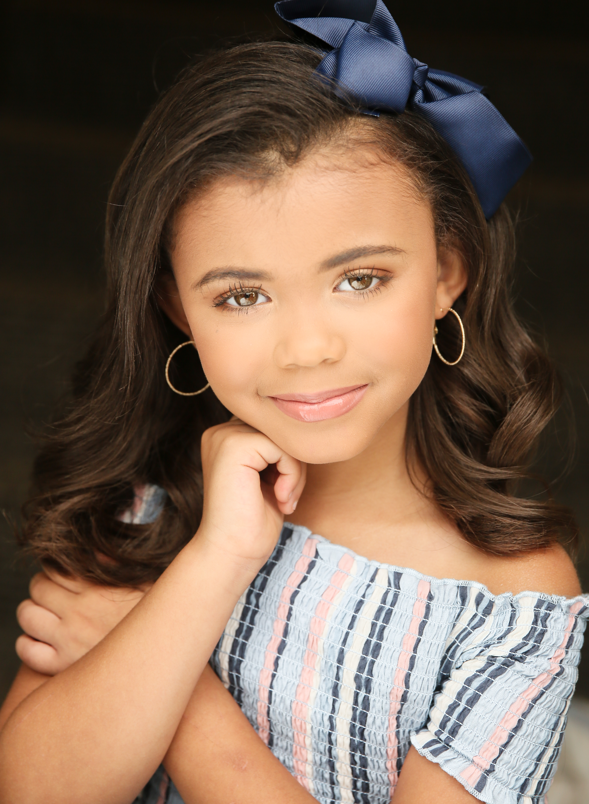

Arabella Grace Johnson

Hello!

I am performing in the 2020 SouthEast Talent Showcase in Valdosta, Georgia on December 5th at VHS Performing Arts Center.

Agents and Casting Directors from NYC, Atlanta, Orlando and Miami will be scouting for New Faces for Commercials, Films, TV Shows, Print and Runway.

I would love to list you as a Sponsor, and will be thankful to you for helping to increase my interview skills and confidence.

You can make your check payable to SETS.

Many blessings,

